The Snake Game

Submitted by

PANKAJ – 25MCD10027

in partial fulfillment for the award of the degree of

Masters Of Computer Application
IN
Data Science


Chandigarh University
Oct. 2025

ACKNOWLEDGEMENT

I would like to express my sincere and heartfelt gratitude to Saranjeet Kaur Ma’am for her continuous guidance, patience, and encouragement throughout the completion of this project. Her valuable insights, constructive feedback, and constant motivation inspired me to stay curious and disciplined while developing this Snake Game project. Her deep knowledge of programming and logical problem-solving has been an invaluable source of learning, helping me strengthen my understanding of Python and its practical applications. Working under her guidance has not only improved my technical abilities but also enhanced my confidence in approaching complex coding challenges.
I would also like to extend my appreciation to all my faculty members in the Department of Computer Science for creating an engaging academic environment that constantly encourages innovation, exploration, and creativity. The classroom sessions, lab hours, and practical demonstrations provided me with a solid foundation in programming concepts, which were crucial for designing and implementing this project effectively.
A special note of thanks goes to my friends and classmates, who provided constant encouragement, support, and valuable suggestions during the development of the project. Their ideas helped me refine the user interface, improve the gameplay experience, and identify minor issues that needed fixing. Collaborating and discussing with them made this project not only an academic exercise but also a fun and memorable learning journey.
I am deeply grateful to the college administration for providing the necessary resources, computer lab facilities, and technical support that made the practical implementation of this project possible. Having access to the right tools and environment allowed me to experiment freely and learn through hands-on experience, which played a major role in successfully completing this work.
Lastly, I wish to thank my family for their endless encouragement, understanding, and emotional support throughout my studies. Their belief in me has always been my greatest source of strength and motivation. Without their support, the completion of this project would not have been possible.
Developing this Snake Game has been an enriching experience that allowed me to connect the theoretical knowledge gained in class with real-world programming practice. It helped me understand how logic, algorithms, and creativity come together to build something functional and enjoyable. This project has strengthened my passion for coding and problem-solving, and I am confident that the skills I have gained through this journey will help me in my future academic and professional endeavors.

1. ANALYSIS / CRITICAL THINKING
The classic Snake Game is a simple yet powerful example of how logic, programming, and creativity can come together to make an interactive experience. Before writing the code, I analyzed the main tasks the game should perform:
- The snake should move continuously in one direction until the player changes it.
- The player should be able to control the direction using keyboard keys.
- Food should appear at random positions on the screen.
- Each time the snake eats the food, it should grow longer and increase the score.
- If the snake hits the wall or its own body, the game should reset.
Thinking through these problems helped me break them into smaller parts that could be solved with code.
For example:
- The snake’s motion could be done using simple coordinate changes.
- Collision detection could be handled using distance between objects.
- Random food placement could use Python’s random module.
This logical breakdown helped me understand how to structure a game loop and how each component interacts. The project strengthened my ability to think step-by-step and debug issues logically, which is an important skill for any programmer.

2. PROJECT DESIGN AND IMPLEMENTATION / TECHNICAL IMPLEMENTATION
2.1 Objective
The main objective of this project is to develop a simple, fun, and interactive version of the traditional Snake Game using Python.
It is designed to improve understanding of:
- Game loops
- Real-time movement
- Collision detection
- Event handling with user input
The focus is not on complex graphics but on the working logic behind a basic 2D game.

2.2 Tools and Libraries
- Python: The programming language used to write the game.
- turtle: A graphics module that allows drawing shapes and controlling objects easily.
- time: Used to add small pauses between movements, controlling the game’s speed.
- random: Helps in generating random x and y coordinates for placing the food.
- tkinter: Works internally with turtle to handle the window and user inputs.
These libraries together make it possible to create a game window, draw moving shapes, detect collisions, and respond to player controls.

2.3 Design Overview
The game screen is set to a size of 600x600 pixels.
- The snake is made up of a head and a list of smaller squares that form its body (segments).
- The food is a small red circle that appears randomly on the screen each time the snake eats it.
- The scoreboard is displayed at the top of the screen showing both current score and high score.
The snake moves by continuously updating its position in small steps. The player can press arrow keys or “W, A, S, D” to change direction. When the snake eats the food, a new body segment is added at the end, and the score increases. The game also gets slightly faster after each food is eaten to make it more challenging.
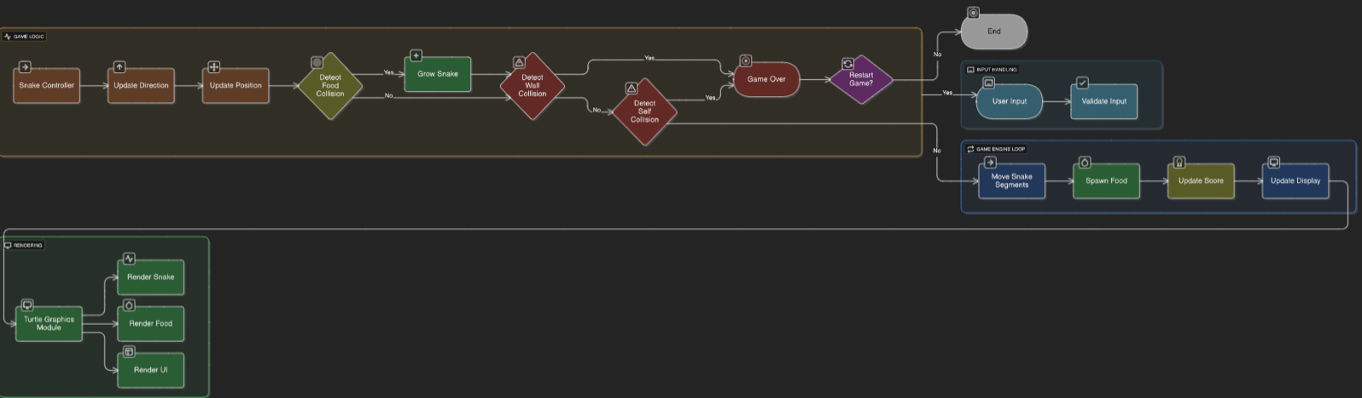

2.4 Algorithm (Step-by-Step Explanation)
- Start the Program
  - Import required libraries (turtle, time, random).
  - Create a window using turtle.Screen() and set its background color, title, and size.
- Create Game Objects
  - Create the snake’s head using a turtle square.
  - Create three initial body segments.
  - Create the food as a red circle.
  - Initialize score variables.
- Define Movement Functions
  - Define four functions: go_up(), go_down(), go_left(), and go_right() to change the snake’s direction.
  - Bind these functions to keyboard keys.
- Start Main Game Loop
  - Update the screen repeatedly using win.update().
  - Move the snake’s head based on its direction.
  - Move each body segment to follow the one before it.
- Collision Detection
  - Food Collision: If the snake’s head touches the food:
    - Move food to a new random location.
    - Add a new segment to the snake’s tail.
    - Increase the score and speed.
  - Wall Collision: If the head crosses the boundary, reset the game.
  - Body Collision: If the head touches any segment, reset the game.
- Display Score
  - Continuously update the score at the top of the screen.
- Repeat
  - The loop keeps running until the player closes the game window.
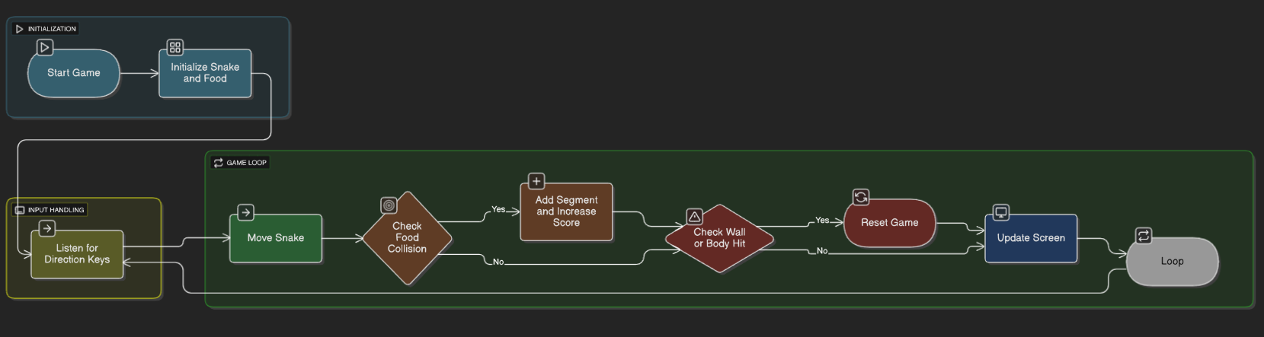

2.5 Implementation Details
- Movement Control: The snake moves by changing its (x, y) position. Each frame, the head’s position is updated, and every body segment follows the one before it.
- Food Positioning: Food appears at random coordinates using:
- random.randint(-BOUNDARY // STEP + 1, BOUNDARY // STEP - 1)
- Game Speed: The delay between frames starts at 0.12 seconds and decreases slightly as the score increases.
- Reset Mechanism: On collision, the snake returns to the center, the score resets, and the screen updates instantly.
- Graphics: The turtle module automatically handles the shape drawing and movement animations.

2.6 Output
When the program is executed:
- A window appears with a dark gray background and a green snake at the center.
- The snake starts moving once the player presses a key.
- Each time the snake eats red food, it grows longer and the score increases.
- If the snake hits the wall or itself, the game restarts with the score reset.
- The player can keep improving their high score as long as they keep playing.
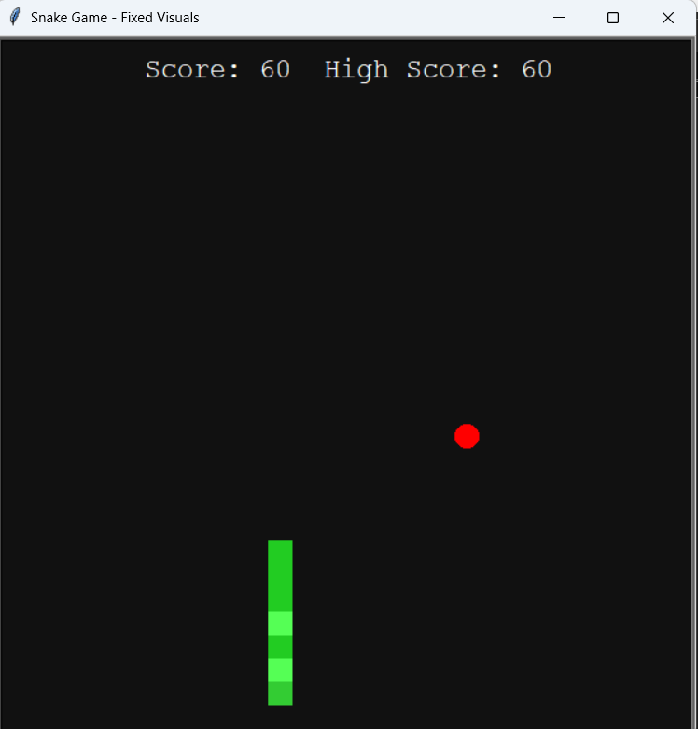

3. ABBREVIATIONS AND SYMBOLS
Abbreviation / Symbol | Meaning
STEP | Distance the snake moves each time
DELAY | Time between each movement (controls speed)
BOUNDARY | Playable area of the screen
xcor(), ycor() | Current coordinates of the turtle
win | The main game window
head | Snake’s head object
segments | List storing body parts of the snake
food | Turtle object representing food
score_display | Turtle object used for writing score on screen

